**Aqueous Solutions & Acidity**

|  |  |
| --- | --- |
| **Acids**: | **Bases**: |
| Taste sour | Taste bitter |
| pH less than 7 | pH greater than 7 |
| Conduct electricity | Conduct electricity |
| Corrosive (cause chemical burns) | Caustic (cause chemical burns) |
| Turns litmus red | Turns litmus blue |
| Slippery, soapy feel |  |

Metal oxides are basic.

K2O 🡪 2K+ + O2–

O2– + H2O 🡪 2OH–

Non-metal oxides are acidic.

SO2 + H2O [double arrow] H2SO4

H2SO4 🡪 2H+ + SO42–

H3PO4 [double arrow] H2PO4– + H+

H2PO4– 🡪 HPO42– + H+

HPO42– 🡪 PO43– + H+

**Q: 632mL of 291ppm copper(II) sulfate solution is mixed with 1mL of 1.00mol L-1 sodium sulfide solution.**

**[a] Write balanced equation and net ionic equation.**

CuSO4 (aq) + Na2S (aq) 🡪 CuS (s) + Na2SO4 (aq)

Cu2+(aq) + S2–(aq) 🡪 CuS (s)

**[b] Write observations.**

A blue solution is combined with a colourless solution, forming a black precipitate.

**[c] What mass of precipitate forms?**

m(CuSO4) = 0.184g

n(CuSO4) = = 0.00115mol

m(NaS) = 0.001 x 1 = 0.001

NaS is the limiting reagent as it produces less CuS.

m(CuS) = 0.001 x M(CuS) = 0.0956g

**Q: 531g of manganese dissolves in excess phosphoric acid.**

**[a] Write ionic equation.**

3Mn (s) + 2H3PO4 (aq) 🡪 Mg3(PO4)2 (s) + 3H2 (g)

**[b] Write observations.**

A silver solid dissolves in a colourless solution, forming a white precipitate and bubbles of colourless odourless gas.

**[c] What volume of gas is produced?**

n(Mn) = = 9.67mol

mol ratio = 3.22mol

n(H2) = 3 x 3.22 = 9.67mol

V(H2) = 9.67 x 22.71 = 219L

**Q: How many calcium ions are needed to precipitate all the phosphate ions from a 365mL volume of 3.2mol L-1 sodium phosphate solution?**

2Na3PO4 (aq) + 3Ca2+(aq) 🡪 Ca3PO4 (s) + 6Na+(aq)

3Ca2+(aq) + 2PO42–(aq) 🡪 Ca3(PO4)2 (s)

n(Na3PO4) = 0.365 x 3.2 = 1.17mol

mol ratio = = 0.584mol

n(Ca2+) = 3 x 0.584 = 1.75mol

#Ca2+ = 1.75 x 6.022 x 1023 = 1.1 x 1024

**Q: 124mL of 67ppm barium hydroxide is mixed with excess magnesium sulfate. What mass of precipitate forms?**

Ba(OH)2 (aq) + MgSO4 (aq) 🡪 BaSO4 (s) + Mg(OH)2 (s)

m(Ba(OH)2) = 0.00831g

n(Ba(OH)2) = = 4.85 x 10-5 mol

n(BaSO4) = n(Ba(OH)2) = 4.85 x 10-5 mol

m(BaSO4) = 0.0113g

n(Mg(OH)2) = n(Ba(OH)2) = 4.85 x 10-5 mol

m(Mg(OH)2) = 0.00283g

m(precipitate) = 0.0113 + 0.00283 = 0.014g

**Q: How many ions are there in 3.99L of 2.71 mol L-1 tin(IV) phosphate solution, assuming it’s soluble?**

Sn3(PO4)4 (aq) 🡪 10.8mol

n(Sn4+) = 3 x 10.8 = 32.4mol

#Sn4+ =32.4 x 6.022 x 1023 = 1.95 x 1025

n(PO43–) = 43.3mol

#PO43– = 43.3 x 6.022 x 1023 = 2.60 x 1025

**Q: Write balanced ionic equations and observations for the following equations:**

**[a] Hydrochloric acid + sodium hydroxide.**

H+ (aq) + OH– (aq) 🡪 H2O (l)

2 colourless solutions are combined with no observable change.

**[b] Ammonium nitrate solid + sodium hydroxide solution.**

NH4NO3 (s) + OH– (aq) 🡪 NH3 (g) + H2O (l)

White solid dissolves in colourless solution, releasing bubbles of colourless, pungent gas.

**[c] Copper (II) sulfate solution + sodium sulfide solution.**

Cu2+ (aq) + S2– (aq) 🡪 CuS (s)

Blue solution and colourless solution are mixed, creating a black precipitate.

**[d] Copper (II) carbonate solid + acetic acid solution.**

CuCO3 (s) + 2CH3COOH (aq) 🡪 Cu2+ (aq) + Co2 (g) + H2O (l) + 2CH3COO– (aq)

Green solid dissolves in colourless solution, creating a blue solution and bubbles of colourless, odourless gas.

**[e] Chromium + nitric acid.**

2Cr (s) + 6H+ (aq) 🡪 2Cr3+ (aq) + 3H2 (g)

Silver solid dissolves in colourless solution, creating a deep green solution and bubbles of colourless, odourless gas.

**[f] Carbon dioxide + barium hydroxide solution.**

CO2 (g) + Ba2+ (aq) + 2OH– (aq) 🡪 BaCO3 (s) + H2O (l)

Colourless, odourless gas is bubbled through a colourless solution, forming a white precipitate.

Q: Write balanced equations (ionic where appropriate) and observations for each of the following:

[a] Ammonium nitrate solution + potassium hydroxide solution.

NH4+(aq) + OH– 🡪 NH3 (g) + H2O (l)

2 colourless solutions are mixed, creating bubbles of colourless pungent gas.

[b] Copper (II) sulfate solution + sodium sulfide solution.

Cu2+(aq) + S2–(aq) 🡪 CuS(s)

A blue solution is mixed with a colourless solution, creating a black precipitate.

[c] Phosphoric acid + calcium carbonate.

2H3PO4 (aq) + 3CaCO3 (s) 🡪 3CO2 (g) + Ca3(PO4)2 (s) + 2PO4– + 3H2O(l)

A white solid dissolves in a colourless solution, creating bubbles of a colourless, odourless gas and a white precipitate.

[d] Hydrofluoric acid + calcium.

Ca(s) + 2HF(aq) 🡪 H2 (g) + 2F–(aq) + Ca2+(aq)

A silver solid dissolves in a colourless solution, creating bubbles of a colourless, odourless gas.

Q: Devise a test to distinguish each of the following pairs of substances. Write observations for each.

[a] Copper carbonate(s) + copper (II) chloride (s).

Add both to water. One green solid will not dissolve. This is the copper (II) carbonate and the other will dissolve creating a blue solution, this is the copper (II) chloride.

[b] Sodium nitrate (aq) + sodium iodide (aq).

Combine both with silver nitrate solution, one colourless solution will mix with the other colourless solution, resulting in no observable change. This is the NaNO3. The other will form a pale yellow precipitate, this is the sodium iodide.

Q: Explain how to create a supersaturated solution of sodium acetate.

1. Heat the water.
2. Dissolve NaCH3COO in the water until no more will dissolve.
3. Remove any excess solid NaCH3COO.
4. Gently cool the solution.

**Q: Determine concentration of silver ions in solution after 1505mL of 3.24 mol L-1 silver nitrate is mixed with 1499mL of 0.545 mol L-1 copper(II) chloride solution.**

2AgNO3 (aq) + CuCl2 (aq) 🡪 2AgCl (s) + CuCl2 (aq)

n(AgNO3) = 3.24 x 1.501 = 4.86 mol

n(CuCl2) = 0.545 x 1.499 = 0.817 mol

n(AgNO3 used) = 2 x n(CuCl2) = 2 x 0.817 = 1.63

n(AgNO3 left) = n(AgNO3) – n(AgNO3 used) = 4.86 – 1.63 = 3.23 mol

n(Ag+) = n(AgNO3 left) = 3.23 mol

c = = 1.08 mol L-1

**Q: What volume of ammonia is produced when 632mL of 343ppm ammonium nitrate reacts with excess sodium hydroxide solution.**

343 =

m(NH4NO3) = 343 x 0.632

m(NH4NO3) = = 0.00271g

NH4NO3 (aq) + NaOH (aq) 🡪 NH3 (g) + H2O (l) + NaNO3 (aq)

n(NH3) = n(NH4NO3) = 0.0027 mol

V(NH3) = 22.71 x n(NH3) = 0.00615L = 61.5mL

Unique properties of water:

* High melting and boiling points (0 °C and 100 °C respectively) – due to strong hydrogen bonds present between molecules (water molecules can form up to four hydrogen bonds per molecule).

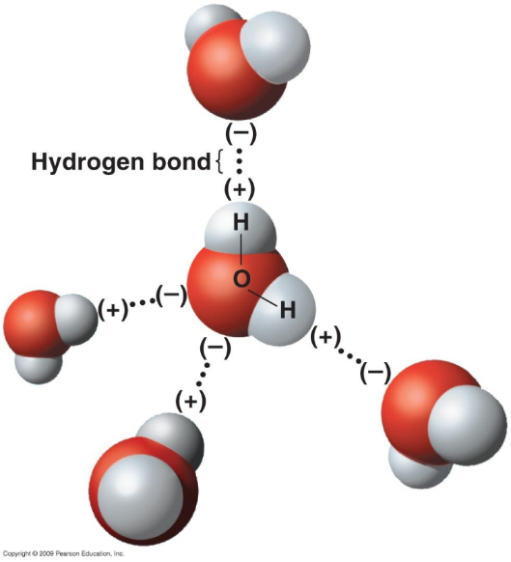

* Density – at 4 °C water has a density around 1.0 g mL-1 and can go as low as 0.934 g mL-1 at ‒180 °C. In solid water, molecules arrange themselves in a tetrahedral arrangement such that the water molecules are further apart in ice than in water.

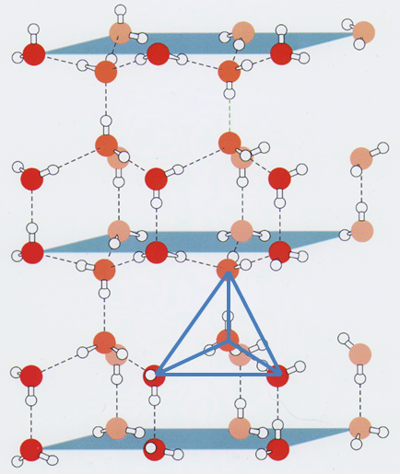

* High surface tension – A liquid’s tendency to reduce its surface area. Due to the strong intermolecular forces at the surface of the liquid being unbalanced, causing the molecules to be pulled inwards.

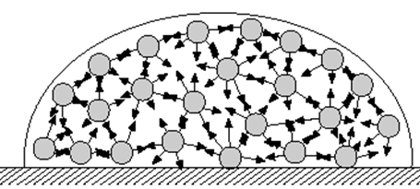

Water is often referred to as the universal solvent because of the large range of substances (solutes) that are soluble in water. The solubility of (and reasons for) various substances in water are:

* Polar substances –solubility in water may be due to favourable hydrogen bonding interactions between the water and polar substance (e.g. methanol in water) or dipole-dipole interactions between the water and polar substance (e.g. hydrogen sulfide in water).
* In order for a solute to be soluble in a solvent, the strength of the interactions between the solute and solvent molecules must be strong enough to overcome the solvent-solvent interactions and the solute-solute interactions (i.e. the energy produced from the formation of the solvent-solute interactions must be greater than the energy required to overcome the solute-solute and solvent-solvent interactions).

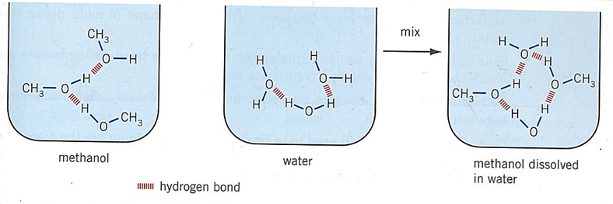

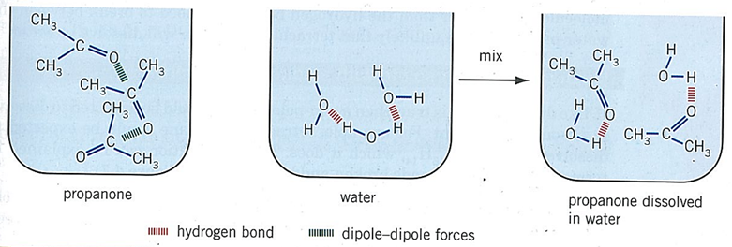

Not all polar substances are soluble in water - dispersion forces can become more and more significant which can then interfere with the favourable intermolecular forces set up between the solute and solvent.

Ionic substances – many are soluble in water due to electrostatic forces of attraction set up between the ions and water molecules called ion-dipole forces. In this type of force positive ions are attracted to the negative end of the water dipole and negative ions are attracted to the positive end of the water dipole.

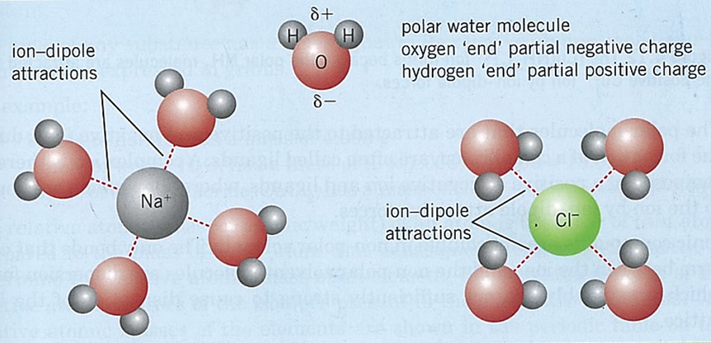

Making supersaturated solution:

* Make saturated solution at high temperature by dissolving solute in solvent.
* Very slowly cool the solution, lowering the solubility below the concentration.

**Q: 2.7L of phosphoric acid is exactly neutralised b y 1.9L of 2.5mol/L sodium hydroxide solution. What’s the concentration of the phosphoric acid in ppm?**

H3PO4 + 3NaOH → Na3PO4+ 3H2O

n(NaOH) = cV = 2.5 x 1.9 = 4.75mol

n(H3PO4) = n(NaOH) = 1.58mol *\* Important step*

m(H3PO4) = nM = 1.58 x (1.008x3 + 30.07 + 16x4) = 155.2g

= 155157mg

c(H3PO4) = = 5500ppm = 57000ppm (2SF)

**Q: 3.7L of sulfuric acid reacts with calcium carbonate producing 132L of CO2. What’s the concentration of acid in mol/L?**

n(CO2) = = 5.81mol

n(H2SO4) = n(CO2) = 5.81mol *\* Important step*

c(H2SO4) = = = 1.6mol/L